|  |
| --- |
|  |
| The Documentation |
| RosePoem Flower Delivery |
|  |
| **Irina Lobova** |
| **11/8/16** |

The abstract: prototyping for RosePoem flower delivery service in NYC. Contains three prototypes for each page: mobile (portrait phone 320px), tablet (portrait 768px) and desktop (large display 1200px). All prototypes are made using Axure RP v.8.0.

1. Pages
   1. Page Tree

Home  
 About Us  
 Delivery  
 Meaning_of_colors

* 1. Home
     1. User Interface

Portrait Phone

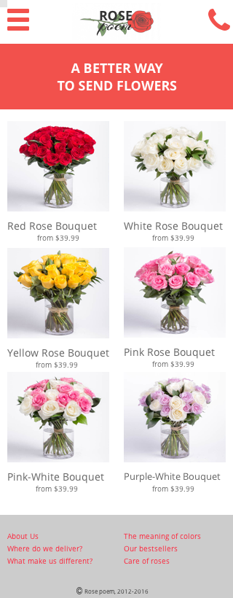

Portrait Tablet

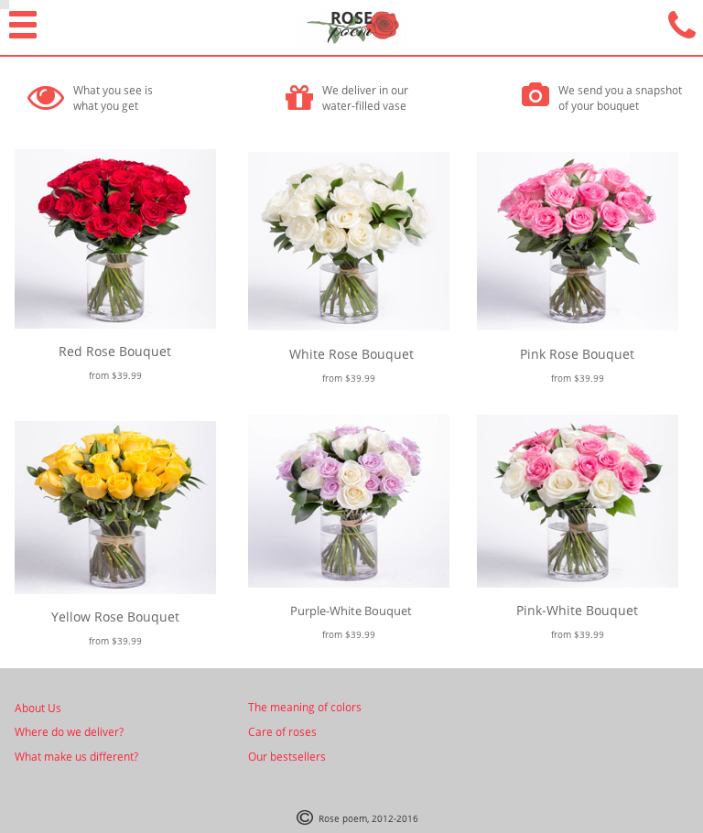

Large Display

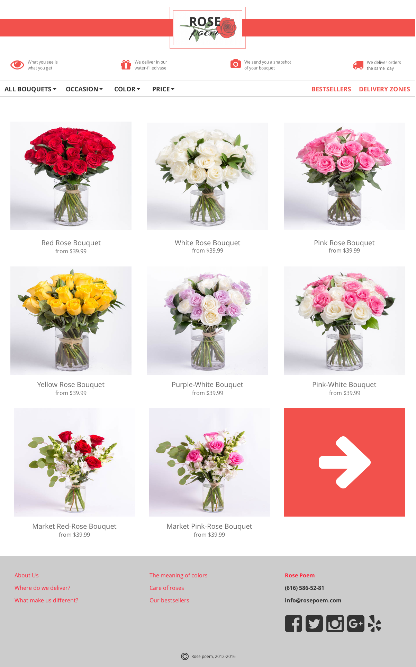

* 1. About Us
     1. User Interface

Portrait Phone

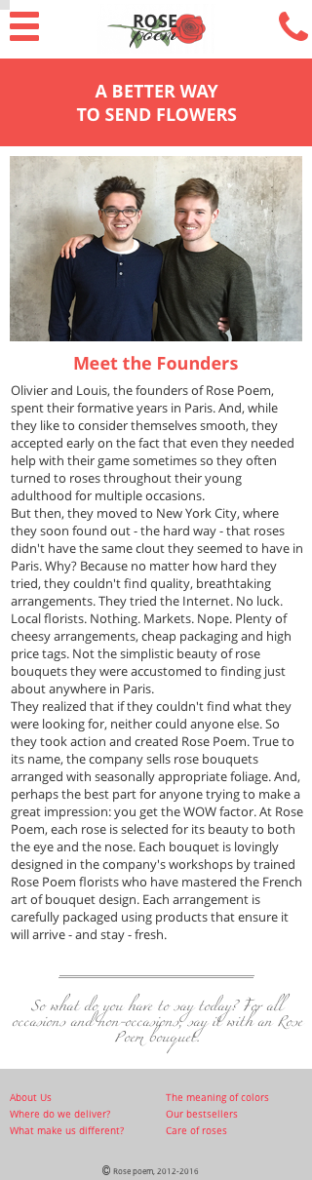

Portrait Tablet

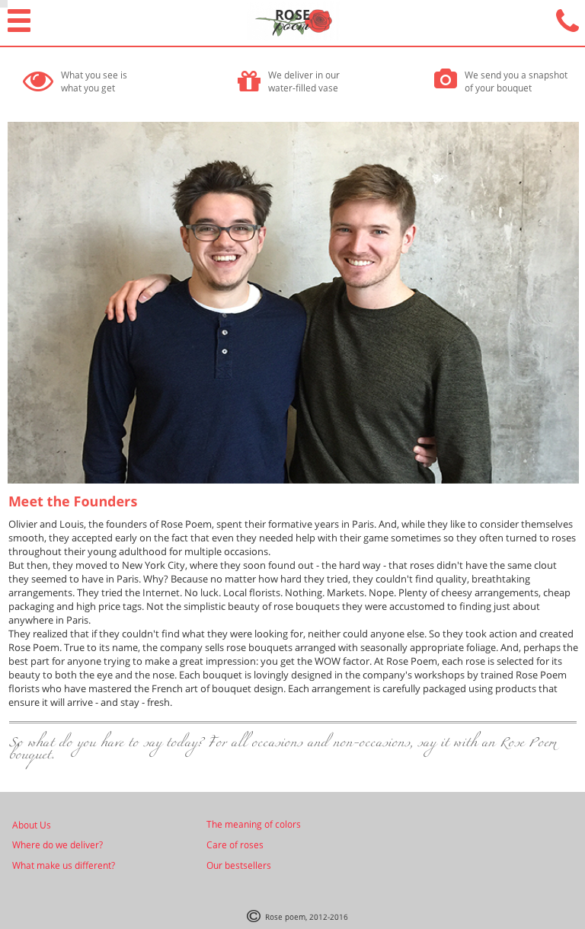

Large Display

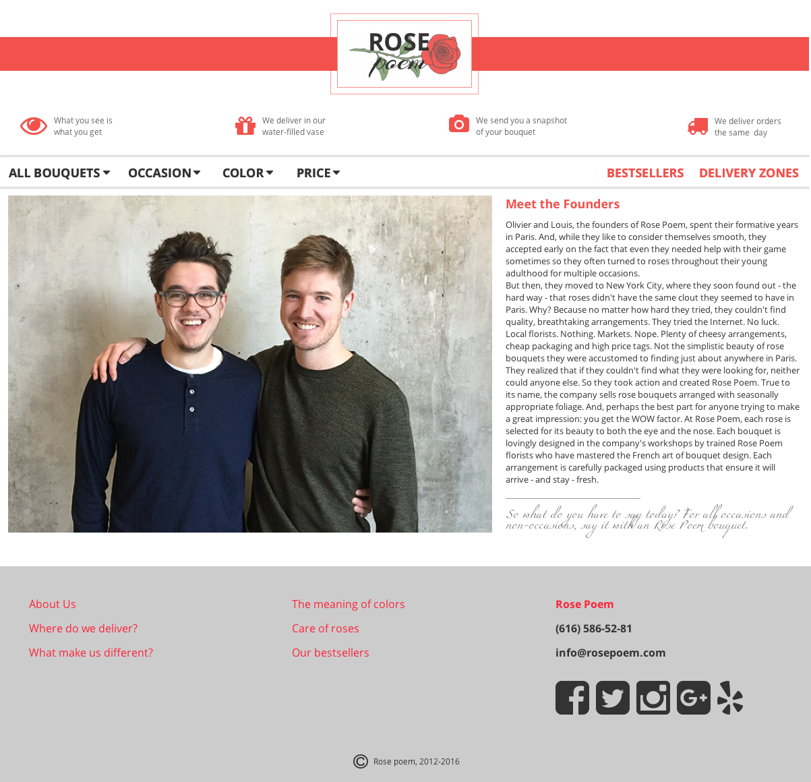

* 1. Delivery
     1. User Interface

Portrait Phone

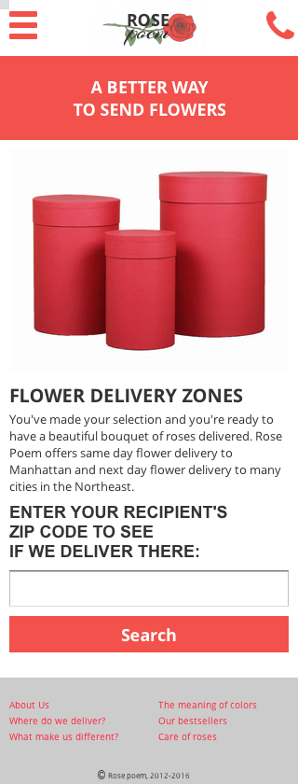

Portrait Tablet

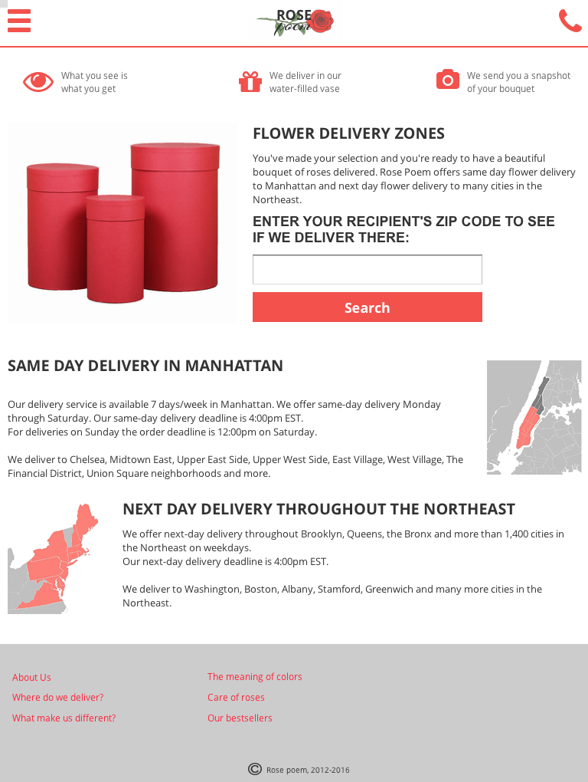

Large Display

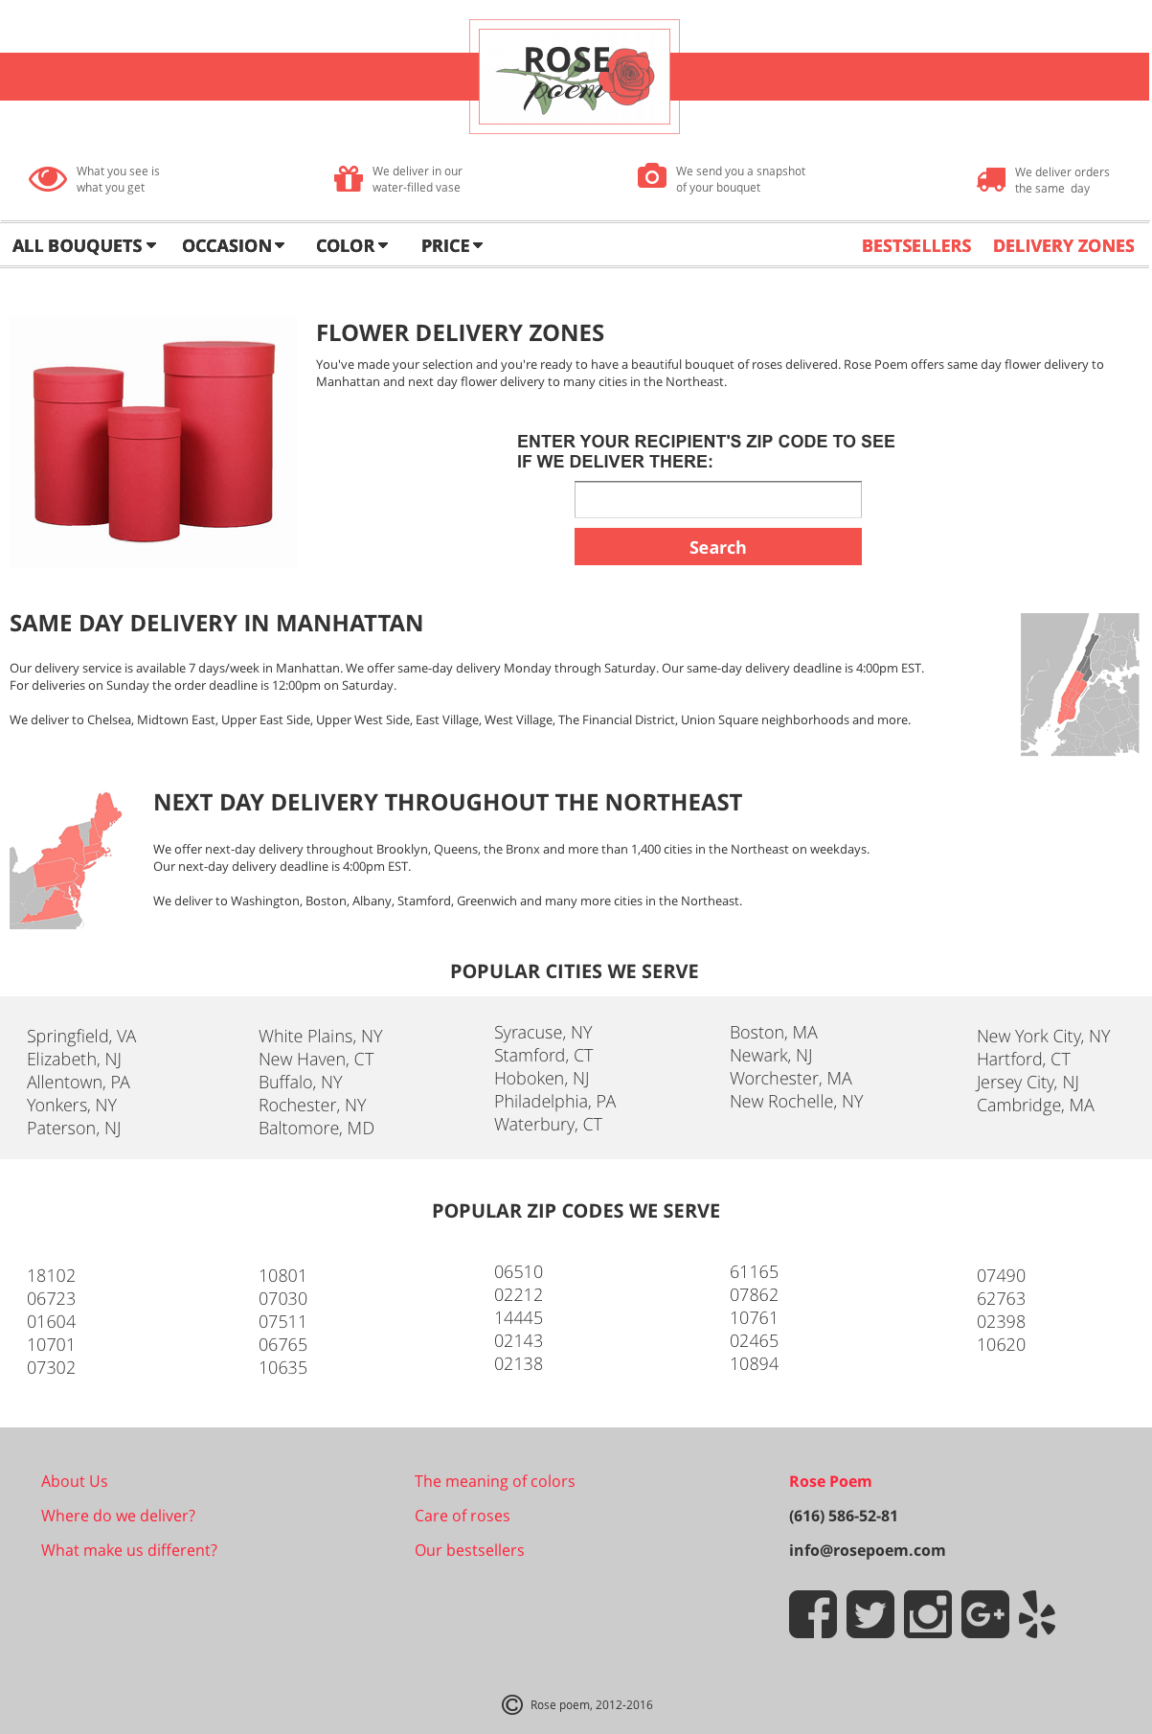

* 1. Meaning_of_colors
     1. User Interface

Portrait Phone

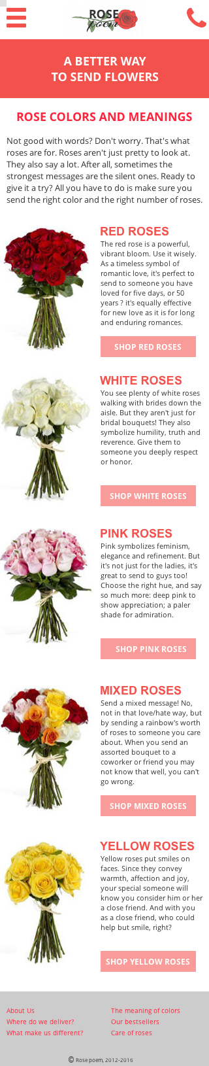

Portrait Tablet

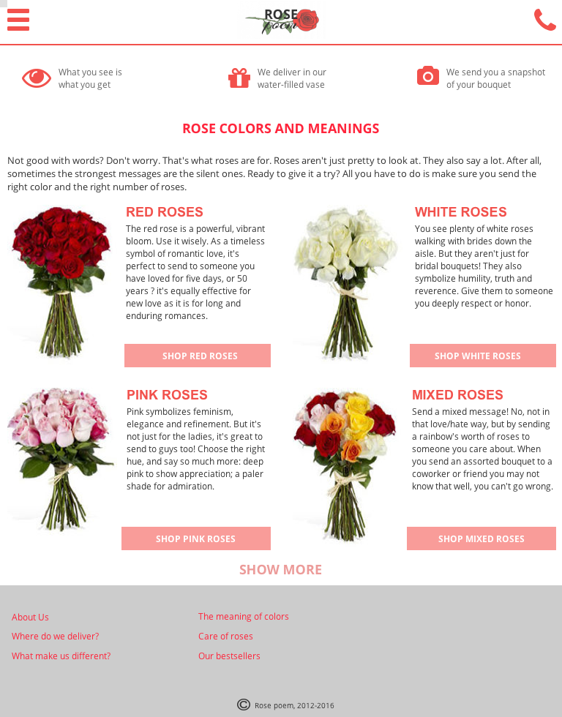

Large Display

